May the fourth be with us… 2021
HEY Y’ALL, HOW’S LIFE?
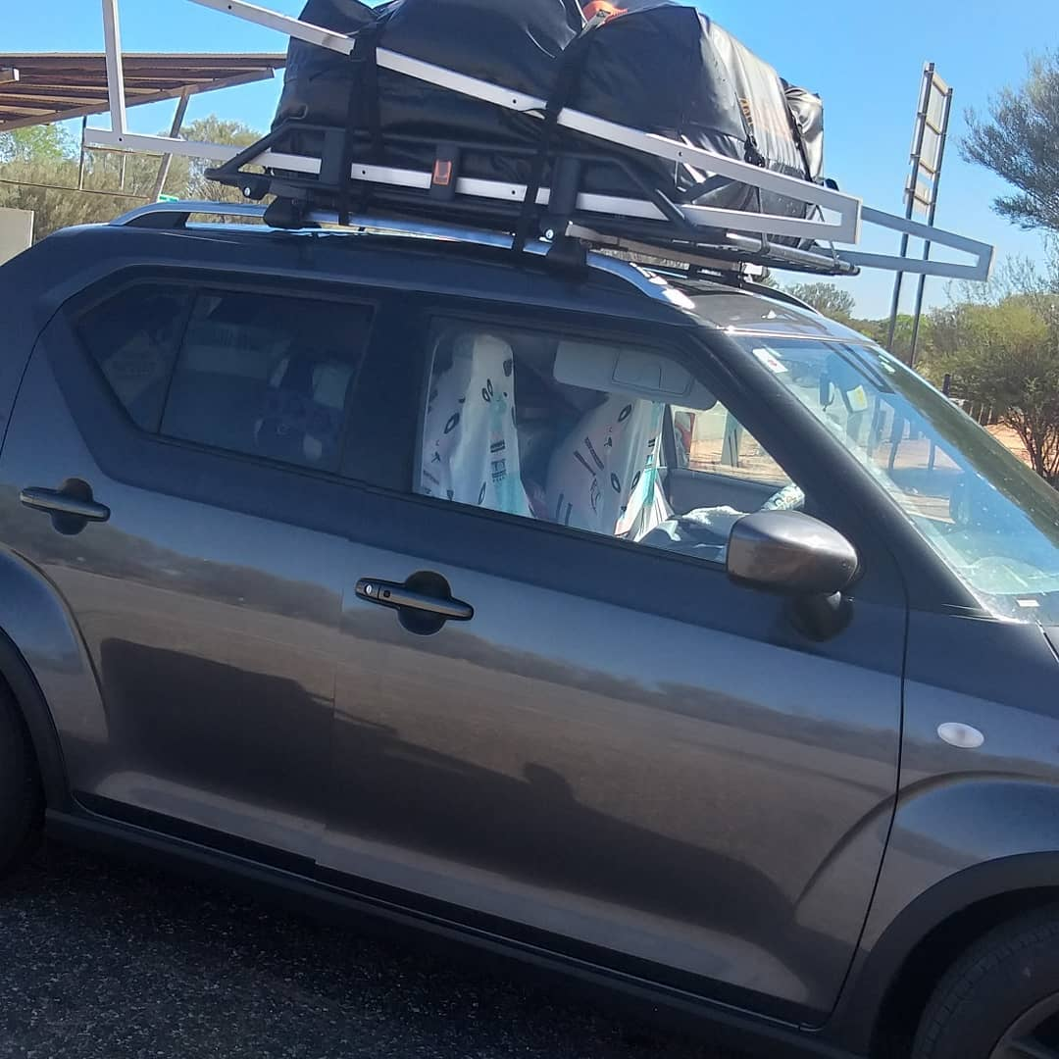
Welcome to May and all the changes that are going on in my life… So last newsletter I told you about my BIG move and you know what – I’ve done it. It was a long, butt numbing drive over 6 days but I’m here now. Being the organised freak that I am, I was all set on packing/moving day, I’d culled down to the bare minimum and was ready to pack my whole life up in my car and head off… then on packing day I realised I’d GROSSLY UNDERESTIMATED how big my car was and so everything but my clothes, sewing machines and tv went to the garbage tip. If you ever wandered what it looks like to have everything you own in life in your car, well…
So I’m all settled into the northern Aussie outback and guess what, it’s not puffy jacket weather here – it’s hot and humid as satans armpit… thank god for end of summer sales and home delivery.
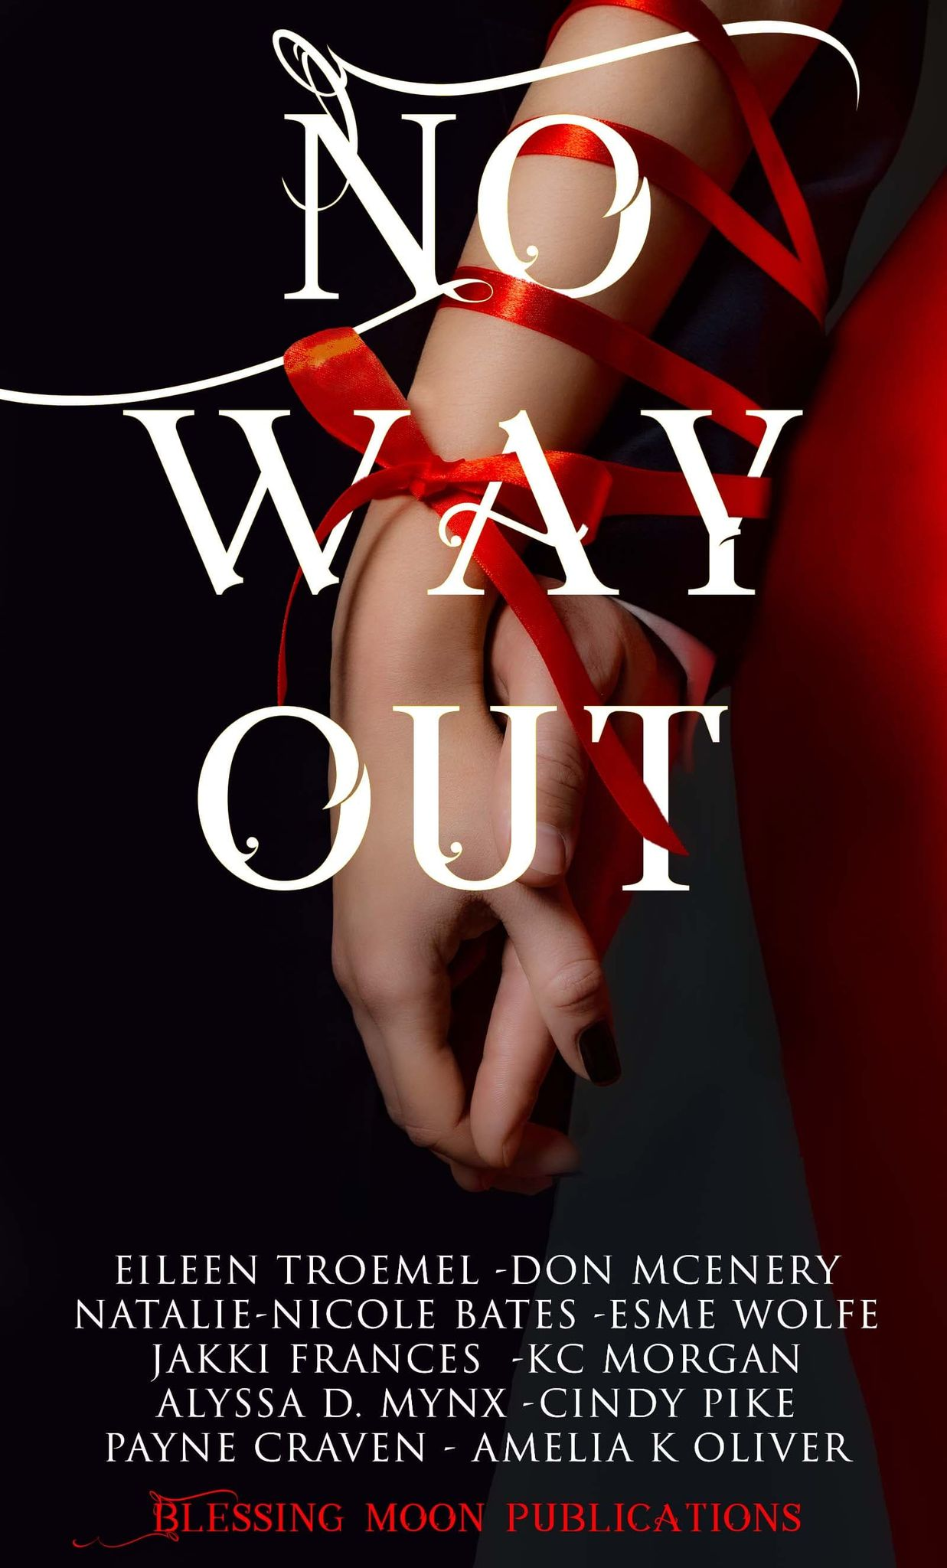
Now I have NEWS SANDWICH…
FIRST THE GOOD NEWS – on 7 May I have a new release – NO WAY OUT!
NO WAY OUT is a fantastic anthology I’m proud to be included in. Each author has brough you a different story with NO WAY OUT. The characters are thrown together in a difficult situation with NO WAY OUT and they must learn to sink or swim so to speak. Can all these people come together in each story and learn to exist together and what will happen if they fail? Find out for yourself…
My contribution FIRESTORM, features an original ANZAC soldier and a modern Melbourne girl who are thrown together by the strangest of circumstances. Can a heroic recluse and a modern waitress really get along when the universe throws them together through time?
Multiple great authors for a bargain price… http://www.amazon.com/dp/20B08YJGYS2G
BAD NEWS TIME...
Unfortunately thanks to continued snap border closures and the whole covid situation –
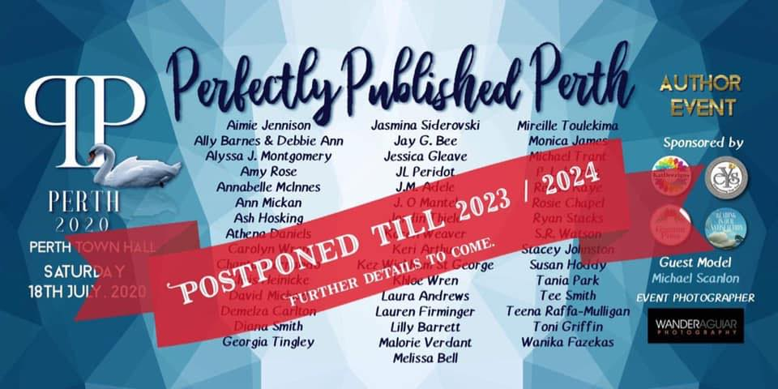
PERFECTLY PUBLISHED PERTH has been postponed until 2023-2034. While it’s disappointing for readers and authors alike, we all understand that it’s just not worth the risk to get crowds together or chance having people become stranded by open/shut state borders. I will however, be there when it does finally go ahead to meet all my wonderful Western readers.
AND NOW SOME MORE GOOD NEWS…
I’m really excited to announce that I’ll be signing at 2 great events in August this year. Those readers in Victoria and Queensland will be able to attend fantastic book events later this year. So jump online and book your tickets to your closest event and come chat with me and a bunch of other great authors who quite frankly I’m fangirling over getting the chance to sign with.
https://www.facebook.com/groups/328106884493327
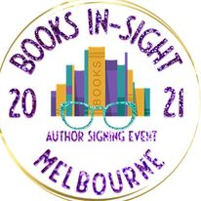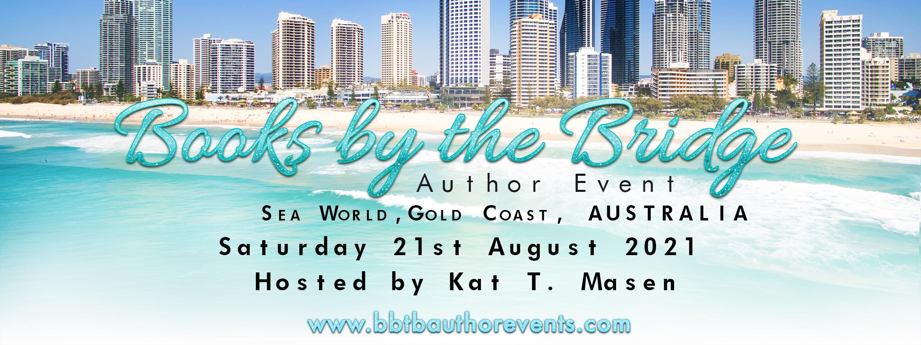
https://www.facebook.com/groups/booksinsightmelbourne
Jump onto these great signings FB pages to take a look see who’s joining me, find ticket links, pre-orders and all the fun planned for the day. CAN’T WAIT TO SEE YOU ALL THERE… I’ll be premiering Wailing Wiccan at these signings.
And on that note, the story is coming together nicely, slowly but surely. And of course I have dozens of other story ideas buzzing around in my head just bursting to be on pages for your reading pleasure.

SO THERE YOU HAVE IT FRIENDS – the butt numbing, boob sweating life of an author who transplanted herself to the sweat capital of Australia. I hope you’re all muddling through your lives while watching me stumble blindly through mine. Can’t wait to hear what you all think of NO WAY OUT…

HAPPY READING FRIENDS

